Class 4 Homework - Jurassic Park Name _________________
 | Maths | Literacy | Science | History/Geography
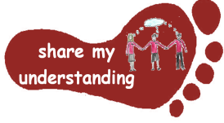  Share my understanding | Work through one of the attached worksheets to show you understand how charts, graphs and tables can be used to represent data.  M1 | Think about which dinosaur is your favourite.  Write a persuasive text, persuading your reader why this dinosaur is the best. Try to use facts to support your ideas. L1 | Show your understanding of the term ‘adaptation’ by choosing an animal and explaining how they have adapted to survive in their environment.  S1 | Create a family tree including photographs if possible.  Add some notes to show any features you feel you have inherited from your relatives.  HG1
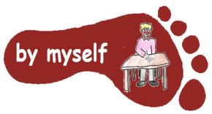  By myself | Write some mathematical dinosaur-related word problems for a friend/your parents/your teacher. Make sure you make an answer sheet.  M2 | Draw a picture of a dinosaur of your choice.  Write a description of this dinosaur using similes, metaphors and powerful adjectives.  L2 | Choose a dinosaur. Find out who were its predators and prey.  Display your findings as a food chain.  S2 | Find out about where different dinosaurs lived across the world. Show your findings on a world map.  HG2
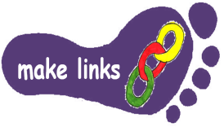  Make links | Find out about the height or weight of different dinosaurs. Present the information you find in a graph/chart/diagram of your choice.  M3 | What did Darwin discover on the Galapagos islands?  Research this and gather information to use to write an article reporting his findings.  L3 | Choose a piece of food from your fridge/cupboard at home. Think about how an animal might need to be adapted to eat this, for example, would it need sharp teeth to bite it or fingers to hold it? S3 | Research the sorts of environments and climates that dinosaurs liked.  Use your research to design and draw/build an environment suitable for dinosaurs.  HG3
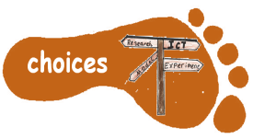  Make choices | Do a rough drawing of a dinosaur of your choice on graph paper. Rotate it through both 180 degrees and 90 degrees to the right about a point.  M4 | Choose your favourite dinosaur book/film (if you don’t know any, ask family and friends for ideas).  Write a book/film review for it.  L4 | Find out about how fossils are created.  Choose how you present this information (for example, you could make a poster or PowerPoint).  S4 | Using Plasticene, modelling clay or any other material of your choice, create your own fossil.  HG4
This is the last homework grid for this year. I would like you to do FIVE activities from the grid. Do at least one task from each subject area and aim for one from each Footstep. Please label your work with YOUR NAME and the code on the grid. Colour the grid as you go to keep track of the tasks you have done. If it’s a practical task, a signature from your parent on the grid is needed. The maths tasks are all attached to this sheet. The grids will be collected in and all tasks need to be completed by MONDAY 14th July. Enjoy choosing and carrying out the tasks. I look forward to finding out what you have been learning at home. Miss Leech

