Class 4 Homework - Crime and Punishment Name _____________
 | Maths | Literacy | History
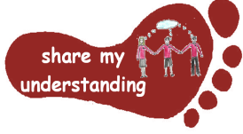  Share my understanding | Choose an area of Maths you are finding challenging. Use Bitesize or another revision resource to work on this. Then create a revision poster to remind you how to do it.  M1 | Imagine a crime trial taking place in a court. Write a short play script for the trial. Think about what characters would be needed and what they might say and do. (You could even act it out and film it!)  L1 | Create your own timeline to show how attitudes to crime and punishment have changed over time. Start from 1066 and work through to the present time.  H1
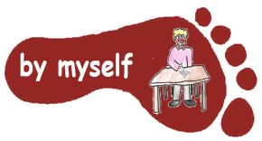  By myself | Work through one of the attached Maths worksheets.  M2 | Read a crime story of your choice and then write a book review for it.  L2 | Find out about the Magna Carta charter. Why was this charter so important? What impact did it have on crime and punishment at the time it was written?  H2
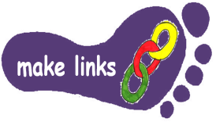  Make links | Think carefully about your knowledge of cubes. Work through the nets of cubes investigation attached.  M3 | Write a crime story of your own. Try to use a range of figurative language techniques (similes, metaphors, personification, amazing adjectives…).  L3 | Design your own court room. Think about where each person would sit and how everyone would be kept safe. You could draw a picture or make a model of it.  H3
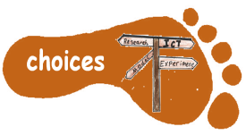  Make choices | Go to the Topmarks website: https://www.topmarks.co.uk/  Explore the games based on fractions, decimals and percentages to help you practise your skills.  M4 | Find out about a crime which has recently been in the news. Write your own newspaper report about this.  L4 | Choose a period of time in British history between 1066 and the present. Find out about crime and punishment at this time and write up your findings as a non-chronological report.  H4
I would like Year 5 to do FIVE activities and Year 6 to do THREE activities from the grid. Do at least one task from each subject area and aim for tasks from different footsteps. Please label your work with YOUR NAME and the code on the grid. Colour the grid as you go to keep track of the tasks you have done. If it’s a practical task, a signature from your parent on the grid is needed. The grids will be collected in and all tasks need to be completed by Tuesday 27th May.
Enjoy choosing and carrying out the tasks. I look forward to finding out what you have been learning at home. Miss Leech

