Class 4 Homework - Bright Sparks Name _____________
 | Maths | Literacy | Science | The Environment
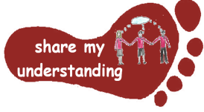  Share my understanding | Create your own fraction wall to help you with equivalent fractions. Come up with a few addition and subtraction number sentences using related fractions and use your fraction wall to help you solve.  M1 | Create a health and safety poster or leaflet about how to stay safe when working with electrical items.  L1 | Look inside a torch; find out how the circuit has been put together. Draw a circuit diagram to show what you found.  S1 | Create an advert for an item which has less of an impact on the environment than others. For example, an electric car, a solar powered light, a glass milk bottle…  E1
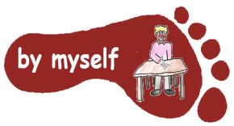  By myself | Locate your gas or electricity meter in your house. Have a look to see how this records your household usage. Each day, for one week, record the meter reading, and then work out your average use per day.  M2 | Work through the attached reading comprehension all about electricity.  L2 | Complete the attached worksheet to find out more about how you use electricity and how much of this is essential and non-essential.  S2 | Design (and you might even want to make!) your own recycling bin which can help you to recycle different materials.  E2
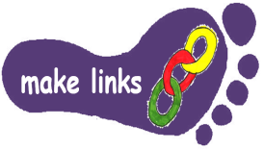  Make links | Ask your parents if you can have a look at one of their energy bills (gas or electric). Use this bill to explore how much your family uses per person each day, week, month and year. M3 | Write a set of instructions for pupils in Class 3 explaining how to make a simple circuit to light a bulb.  L3 | Explore the website:  www.switchedonkids.org.uk  There are lots of things to find out, games to play and quizzes to test your knowledge!  S3 | Go on an ‘Energy Saving Mission’ at home to help you and your family save energy. Use the sheets attached to guide you through.  E3
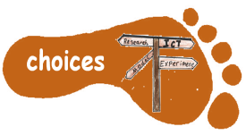  Make choices | Complete one of the attached maths sheets to help you practise working with fractions.  M4 | Research a famous inventor of your choice who has invented electrical items. You could present your findings as a fact page, Powerpoint, poster…  L4 | There are lots of packs you can purchase to build your own circuits and make different electrical items. You might like to try completing one of these.  S4 | Find out about a renewable energy source of your choice (e.g. wind, solar or hydroelectric power) and write up your findings in a fact page. E4
I would like Year 5 pupils to complete FIVE activities and Year 6 pupils to complete THREE activities from the grid. Do at least one task from each subject area and aim for tasks from different footsteps. Please label your work with YOUR NAME and the code on the grid. If it’s a practical task, you could bring it in, send in a photo or ask your parent to sign on the grid to show it has been completed. The grids will be collected in and all tasks need to be completed by Monday 31st March. Enjoy choosing and carrying out the tasks. I look forward to finding out what you have been learning at home. Miss Leech

