Class 4 Homework - Mysterious Maya Civilisation Name _____________
 | Maths | Literacy | Art / DT | History/Geography
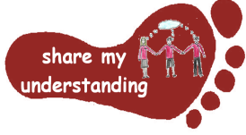  Share my understanding | Find out about the Maya number system. Explain how this system worked. Try writing some different number sentences using this system.  M1 | Write an information leaflet about the Maya civilisation, sharing important facts about these people and their lifestyles.  L1 | Create a headdress in the traditional Maya style.  A1 | Create a timeline to show how the Maya civilisation developed over time.  HG1
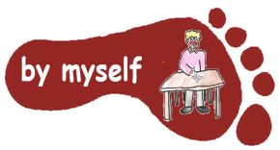  By myself | Explore the Maya maths games at: maya.nmai.si.edu/maya-sun/maya-math-game  If you can’t find this then try going on Google and searching ‘Maya maths activities’.  M2 | Read a Maya myth or legend of your choice. Then summarise what it is about in your own words.  L2 | Make a model of a Maya town or village.  A2 | Find out about one of the Maya settlements. Show where the settlement was on a map and share the information you find out about it.  HG2
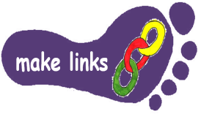  Make links | Work through the ‘Maya Number System’ sheet using what you have learnt about Maya numbers to help you.  M3 | Pretend you are a Maya soldier. Write a diary entry to show what life is like for you.  L3 | Find out about Maya Codex and create your own Codex.  A3 | Find out how archaeologists and historians have found out more about the Maya civilisation over time.  HG3
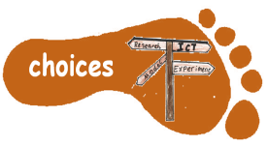  Make choices | Create your own Maya number problems for us to solve in class. Make sure you prepare an answer sheet so we can check our answers!  M4 | Find out about an aspect of Maya life which interests you. Write a non-chronological report (fact page) to share what you find out.  L4 | Find out about the food Maya people ate. Try some of these food items at home.  A4 | Find out about a famous person from the Maya civilisation and create a fact sheet or Powerpoint Presentation about them.  HG4
I would like Year 5 children to complete FIVE activities from the grid and Year 6 children to complete THREE activities, due to their extra SATs preparation work. Do at least one task from each subject area and aim for one from each Footstep. Please label your work with YOUR NAME and the code on the grid. Colour the grid as you go to keep track of the tasks you have done. If it’s a practical task, a signature from your parent on the grid is needed. The maths tasks are all attached to this sheet. The grids will be collected in and all tasks need to be completed by MONDAY 3rd February.
Enjoy choosing and carrying out the tasks. I look forward to finding out what you have been learning at home. Miss Leech

