Badger Class Homework – Summer Two ‘Its a Bug’s Life’ Name ______________
 | Maths | English | Science | Creative
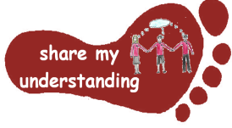  Share my understanding | Grow your own plant at home. Record how much it grows each day over a set period of time. Show your results using a chart or graph.  M1 | Find out about an animal or plant of your choice. Create a Powerpoint or non-chronological report to share the facts you find out.  E1 | Find out about a famous naturalist and their contribution to Science and write a biography or fact file eg Gilbert White, David Attenborough, Carl Linnaeus, Chris Packham S1 | Create a bird feeder for your garden and then keep watch and make a list of all the birds you see in your garden.  C1
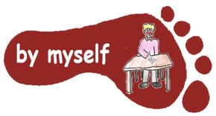  By myself | Complete the Animal and Plant Worded Problems. Remember to show your workings.  M2 | Read through the Minibeasts Reading Comprehension and answer the questions.  E2 | Play the Animal Life Cycles Game with your friends or family to see how much you know about life cycles. Who will be the first to construct the full life cycle? S2 | Create your own animal home. This could be for a bug or a bigger animal. Think carefully about what type of home your animal will need.  C2
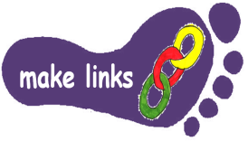  Make links | Complete the Zoo Mystery task. You will have to make links to lots of different areas of Maths knowledge.  M3 | Read the poem ‘One Broken Planet’. How could we tackle each of the issues in the poem? Research and write notes on what people are doing or can do to help with each issue. E3 | Choose a country you are interested in. Find out about which animals live there. How have they adapted to survive in that country’s climate?  S3 | Create a nature-inspired artwork. This could be a sculpture using natural materials or a painting, drawing or model of a plant or animal.  C3
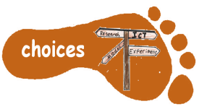  Make choices | Create your own set of worded problems linked to our topic. Make sure you include an answer sheet!  M4 | After reading The Last Bear by Hannah Gold, complete the Crossword Puzzle. Can you create your own quiz based on the book?  E4 | Test your Science knowledge of Living Things and Their Habitats by completing the Escape the Safari Park Activity. How quickly can you solve all the sclues? S4 | Create your own piece of nature-themed cooking eg chocolate bat biscuits, polar bear peppermint creams, hedgehog rolls, or use foraged food such as blackberries.  C4
I would like you to do FIVE activities from the grid. Do one task from each subject area and aim for one from each Footstep. Please label your work with YOUR NAME and the code on the grid. Colour the grid as you go to keep track of the tasks you have done. If it’s a practical task, a signature from your parent on the grid is needed. If tasks require any printed activity sheets (shown in bold), these can be requested via email or collected from the Yellow Homework folder in the classroom. The grids will be collected in and all tasks need to be completed by MONDAY 13th July.
Enjoy choosing and carrying out the tasks. I look forward to finding out what you have been learning at home. Miss Leech

