Squirrel Class Spring 1 Term Topic
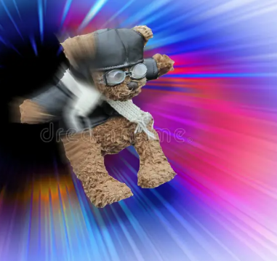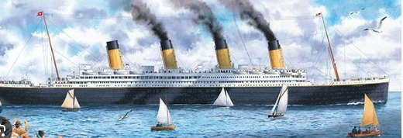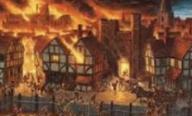

Time Travel Trouble!
A time travelling teddy has arrived in class with a special letter. The children will become historical detectives, researching the Titanic to find out more about it.

We will be learning about the Great Fire of London as part of our history curriculum. We have planned some great activities which will get the children excited about what it was like to sail on board the most luxurious vessel of the time and interested in life in London in 1666.
We are very aware that these topics are of a sensitive nature, particularly for such young children. We will be focusing on how measures have been put into place to ensure these tragedies do not occur again rather than the distressing historic details. If you have any concerns though, please do come and talk to us.
English
Year 1 and Year 2 will continue their daily Little Wandle input alongside their Guided Reading sessions three times a week. Please ensure that the guided reading books are brought back on a Friday.
Year 2 will begin their daily ‘Take Me to Spelling’ Little Wandle programme in addition to their Guided Reading sessions.
Our class book is called ‘Samson’s Titanic Journey’ and from this, the children will be writing letters. We will be reading non-fiction texts and ‘The Baker’s boy and the Great Fire of London, stimulating the children to write diary entries.
It’s going to be a busy half-term of reading and writing fun!

Maths
Year 1 will be learning place value for numbers to 20 and then to 50. We will introduce multiplication and division. Learning how to use arrays, pictorial representations and mentally learning how to count in 2’s, 5’s and 10’s.
Year 2 will be consolidating place value knowledge of numbers to 100. They will and continue learning written methods for all the number operations, addition, subtraction, multiplication and division.
In Science, we will be exploring how materials can change state with a particular focus on water changing to ice.
Diary Dates!

Wednesday 21st January- Class trip to The
SeaCity Museum.

HELP -Spare Clothes Needed
If you have spare girl’s tights, boys underwear, socks- boys/girls and old trousers aged 6-8 yrs please put them in a carrier bag and bring them in to add to our spare clothes box in case any children have accidents.

In RE, we will be learning about Judaism and why Passover is so important.
In Art, we will be using mixed media and collage to create some art work that will be inspired by water or the Great Fire of London.
In Geography, we will be learning about plotting the sailing route of the Titanic at looking at the importance of Southampton as a boat dockyard. We will learn about London as a capital city and how it compares with Upham.
In Computing, we will be learning about Algorithms.
Outdoor PE will be hockey and indoor PE will be gymnastics - travelling between shapes. Please ensure children have jogging bottoms and jumpers in school this term as they will try to do P.E outside, weather permitting.

