

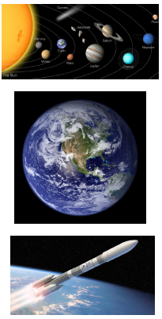
🚀 To Infinity and Beyond! 🌌
This term, Badger Class will embark on an exciting journey through the wonders of space with our topic, ‘To Infinity and Beyond!’ 🪐 The children will explore our fascinating Solar System, discovering the unique characteristics of each planet and their position in relation to the Sun. ☀️ They will investigate how the Earth and other planets orbit the Sun, as well as how the Moon moves in relation to the Earth. 🌍🌙 Through practical investigations and scientific exploration, the children will develop an understanding of how the Earth’s rotation causes day and night. 🌞🌑 Finally, they will journey through history to discover how our knowledge of space has evolved over time, exploring the remarkable discoveries and pioneering ideas that have shaped our understanding of the universe. 🔭✨
📚 English: Powerful Poetry and Persuasive Speeches✍️ This term, Badger Class will explore the power of words through two exciting writing projects! 🖋️ The children will study war poetry, using ‘Dulce et Decorum Est’ by Wilfred Owen as inspiration. 💂‍♂️ Through exploring Owen’s vivid imagery, emotive language and powerful descriptions, they will develop their understanding of how poets convey the horrors of war and evoke strong emotions in their readers🪶. Additionally, keeping in line with our space-themed topic 🚀, ‘To Infinity and Beyond!’, the children will also put their persuasive writing skills to the test by preparing a speech in response to the thought-provoking question: ‘Should we go back to the Moon?’ 🌕 They will research different viewpoints, construct compelling arguments and use rhetorical questions, persuasive language and powerful vocabulary to engage their audience. 🎤 By the end of the term, the children will have developed their ability to write with creativity, confidence and purpose, expressing their ideas in a clear and convincing way. ✨
🔢 Maths: Fractions This term, Badger Class will develop their understanding of fractions, learning to add, subtract, compare and identify equivalent fractions. They will also practise multiplying and dividing fractions, as well as calculating fractions of amounts. Please encourage your child to practise these skills at home to build confidence and consolidate their learning.
Home Help—How can you support your child with this half term’s learning?
Please encourage your child to explore this topic further at home. The homework grid sent out today focuses on our topic and provides a useful starting point. Children are expected to complete four activities this half term.
Please support your child in learning their weekly spellings and practising their times tables. Regular reading of a range of texts is also encouraged.
Additionally, this half term please support your child to learn their lines for the Christmas play — a very exciting event of the term! Thank you for your ongoing support. Miss Leech

