Badger Homework - To Infinity and Beyond Name ___________
 | Maths | Literacy | Art / DT | Science
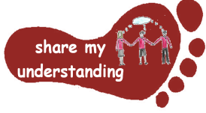  Share my understanding | Work through the space themed word problems attached, make sure you show your workings clearly.  M1 | Research Space Travel as a holiday destination and use the information to create an advert persuading people to go. L1 | Make a model of the solar system.  A1 | Find out about, and explain in your own words, why we experience day and night on Earth.  S1
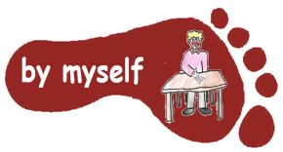  By myself | Work through the attached multiples of 25 and 1000 sheet.  M2 | Work through the attached ‘Mars: The Red Planet’’ reading comprehension and answer the questions.  L2 | Look at ‘Starry Night’ by Vincent Van Gogh. Create your own night-time picture using this as a stimulus.  A2 | Make a simple shadow clock or sundial and explore what happens at different points in the day.  S2
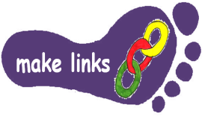  Make links | Complete the cross-number activity. You will need to make links to your times tables and use the short methods for x and ÷. Remember to show your workings. M3 | Read the three attached space-themed poems by Meish Goldish. Then work through the suggested tasks.  L3 | Design and make a model space buggy which could be used to explore the moon. Consider what you already know about the moon (terrain and gravity) when designing. A3 | Find out about one of the following scientists: Ptolemy, Alhazen or Copernicus. How did they help to develop our understanding of the solar system? S3
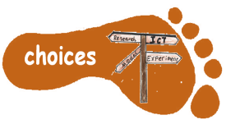  Make choices | Create your own set of space-themed word problems. Make sure you include an answer sheet.  M4 | Read a space-themed story of your choice. Write a book review to share your opinions of it.  L4 | Look at a range of space art on the Internet. Choose a piece which interests you and use this as a stimulus to create your own space art work. A4 | Design a meal for an astronaut to eat in space. Think about how they can eat it (as there’s low or no gravity!) and if it is healthy.  S4

This is the homework grid for this half term. I would like you to do FOUR activities from the grid this half term as you will also be learning your lines for the Christmas Play. Complete one task from each subject area and aim for one from each Footstep. Please label your work with YOUR NAME and the code on the grid. Colour the grid as you go to keep track of the tasks you have done. If it’s a practical task, a signature from your parent on the grid is needed. The Maths and English tasks are attached to this sheet. The grids will be collected in and all tasks need to be completed by MONDAY 14th December. Enjoy choosing and carrying out the tasks. I look forward to finding out what you have been learning at home. Miss Leech

